Economics Chapter 1: What is Economics?
Broken Notes Outline
LESSON ONE
THE MAJOR PROBLEM OF ECONOMICS IS __________________________________
- All ___________________________ are limited
- Human beings have ________________________ and __________________________
- Human beings form ________________________ to get their needs and wants fulfilled in the most ______________________________ way possible.
- In __________________________, societies are made up of ___________________________ (CONSUMERS and LABOR), __________________________ (ENTREPRENEURS and PRODUCERS) and the _________________________(regulation, protection, provision of services)
WHAT IS ECONOMICS?
- _________________________is a ____________________________ that studies how human beings and societies use scarce resources to fulfill their needs and wants
- Wants and needs are often discussed in connection to how much __________________ and _________________________ something has to fulfill the want and need.
- This can lead to a _________________________________________.
- ____________________________ explained about what ____________________ is and that people with all their ______________________ and __________________________ are the true source of wealth is for any nation. He also explained how VALUE is derived in his book ___________________________________________ (1776)
WANTS and NEEDS
- Human beings try to satisfy their __________________ and _______________ through the use of ______________________ and ______________________________
- Goods are categorized into ________________________________ or ____________________________, __________________________________ or______________________________________
- Goods and services take up resources
- In economics, resources are often called ____________________________________________.
CHOICES
- ___________________ have to be made because there aren’t enough__________________________ to satisfy everyone’s wants and needs.
- The problem of not having enough ____________________________ is called _____________________
- When we talk about _____________________________ we have to make because of _____________________, we often talk about what we had to give up to get what we wanted. These choices are called __________________________________ and ___________________________.
MORE CHOICES
- We need to keep in mind that every ________________________________ has a ___________________ associated with it.
- This concept is illustrated by the acronym ______________________________ (There Is No Such Thing As A Free Lunch)
The concept of ____________________________ refers to the fact that ___________ economic product is ever ________________. Someone has to pay for it somewhere: creation, production, shipping distribution, sales, labor, management, and advertising
EVEN MORECHOICES
- __________________________ make choices; individual people make choices as ________________________________; ___________________________ (FIRMS) make choices; the ______________________________________ makes choices
- The choices that societies have to make about resource ___________ and ___________________ can be summed up into __________________________________ every society must ask itself:
  - __________________________ are we going to produce?
  - __________________________are we going to produce it?
  - __________________________gets what we produce?
Because we must make choices about resources, there are 3 Questions all societies must ask
_____________________ ARE WE GOING TO PRODUCE?
- Guns or butter?
- Civilian or military?
- Public or private?
______________________ ARE WE GOING TO PRODUCE?
- Mass produce or piece by piece?
- Human beings or robots?
- Small business or corporation?
____________________ GETS WHAT WE PRODUCE?
- The workers who made them?
- The military?
- Whoever can afford to buy them?
IN OUR ECONOMY, THE ANSWER TO THE QUESTIONS IS (inset box on slide)
- We will make whatever we think will be ________________________ with the resources we have on hand
- We will make them in the most _____________________, cost efficient and resource efficient way
- Whoever can ___________________________ them can get them

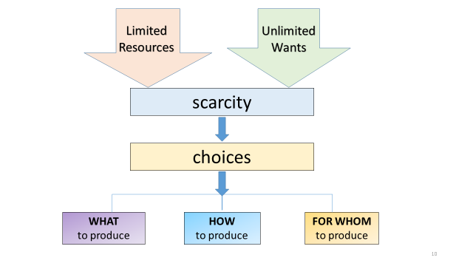

CHAPTER 1 – LESSON 2: OUR ECONOMIC CHOICES

I. Choices _________________________ Make – producers need to figure out what resources they will need and the best way to use them. These resources are called ____________________________________
A. Factors of Production – Resources required to produce the things we want and need. The four factors are _______________, __________________, _________________, _______________________________

1. _____________ – gifts of nature or natural resources not created by people
    - _______________________
    - Minerals
    - Ore
    - _________________________
    - Sunshine
    - __________________________
    - Waterways
    - Deserts

2. __________________ – Used in the production of goods and services. There are ____________________
a. ________________________________ – tools, equipment, machinery and factories used in the production of goods and services.
Examples:
  - A bulldozer at a construction site
  - An ________________ in a bakery
  - A computer in a classroom
  - A _______________________ in a salon
  - An x-ray machine in a hospital
b. ________________________________- the _________________ and __________________needed to purchase capital goods and other factors of production
3. _________________ – people with all their efforts and _____________________ and ______________who help produce goods and services
- Does _________include _____________________________ because they are special and are a factor of production all on their own.
- Historically, factors such as __________________________, _________________________, disease, famine and war have great impacts on the quality and availability of labor.

4. Entrepreneurs- ___________________________ in search of ________________________ who do something new with existing ____________________________.
- Responsible for much of the __________________________, progress and ____________________ in the economy
- They are the driving force or _________________________ of the economy because they start businesses, invent, innovate and bring new products to market.

THE PPC or PPF
The choices that a society makes about resource use and production can be illustrated using a ________________________________________________

NOTES ABOUT THE PPC / PPF WILL BE HANDED OUT SEPERATELY
PUT THOSEPAGES BEHIND THIS SECTION OF NOTES IN YOUR NOTEBOOK

CHAPTER 1-LESSON 3: USING ECONOMIC MODELS

ECONOMIC GROWTH AND INCENTIVES IN ECONOMICS

